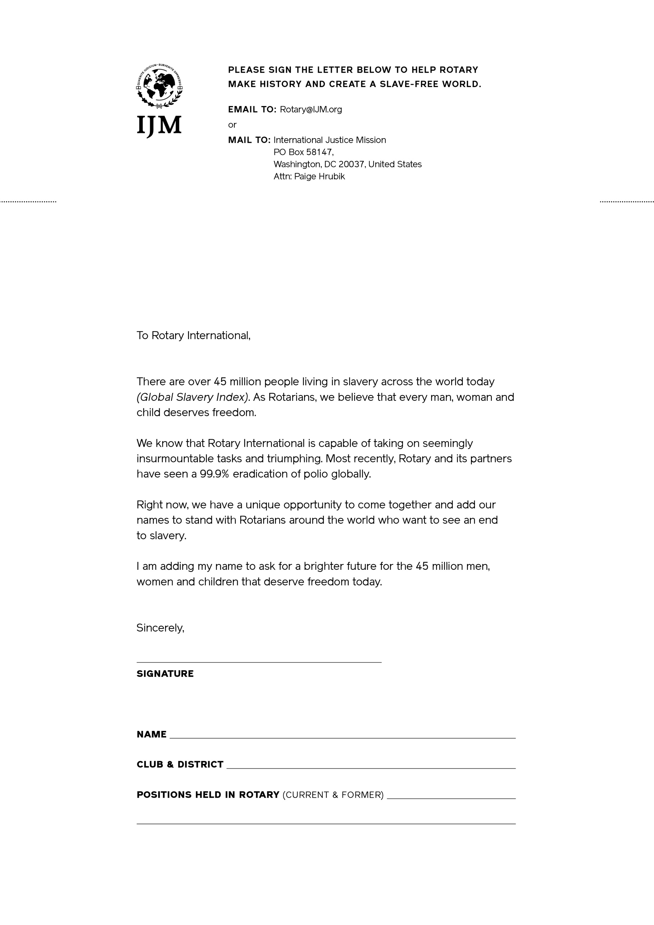­

[Your Name]

[Address]

[Date]